IzPacks laf

**Build**Izpack is independant from JDK version.  
No issue found there with Oracle Java 8 and 11.

**Runtime**Izpack takes the JDK/JRE from the **PATH**  
The installed Jeyzer inherits from this path to set the JAVA_HOME.  
Alternative would be to set it through JDK panel. Not implemented.

**Tests**

Tests done under Windows 10 Pro.   
Installer built with Oracle JDK 11

**https://izpack.atlassian.net/wiki/spaces/IZPACK/pages/491730/GUI+Preferences**

|  |  |  |  |
| --- | --- | --- | --- |
| Laf | Java 8 | Java 11 | Comments |
| substance | OK | NOK | Variant **mist-silver** used for long time on Java 8 Many [Variants](https://github.com/kirill-grouchnikov/radiance/blob/6b86732e00a405cfa65f4c50d0ab79107102a22e/docs/substance/skins/toneddown.md).  Sahara and office black also fail on Java 11. Probably the same for all others. Not maintained anymore Java 11 issue:  <https://izpack.atlassian.net/browse/IZPACK-1594>  <https://github.com/Insubstantial/insubstantial/issues/17> |
| looks | OK | OK | **Now used, with windows variant** [www.jgoodies.com](http://www.jgoodies.com) Variants: windows, plastic, plastic3D, plasticXP |
| kunstoff | Kunstoff | kunstoff | Ugly |
| windows | NRAB | NRAB |  |
| metouia | NRAB | NRAB |  |
| aqua | NRAB | NRAB |  |
| metal | NRAB | NRAB |  |

NRAB : Not recognized at build time.

Substance

## Variant mist-silver

Java 8

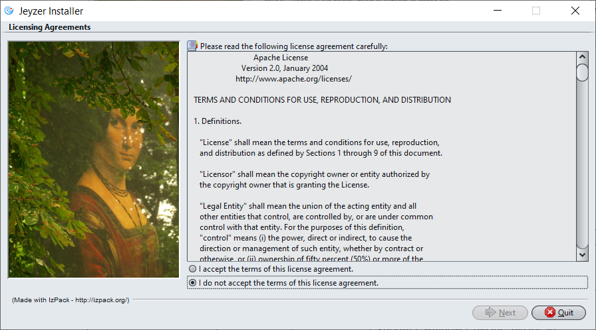

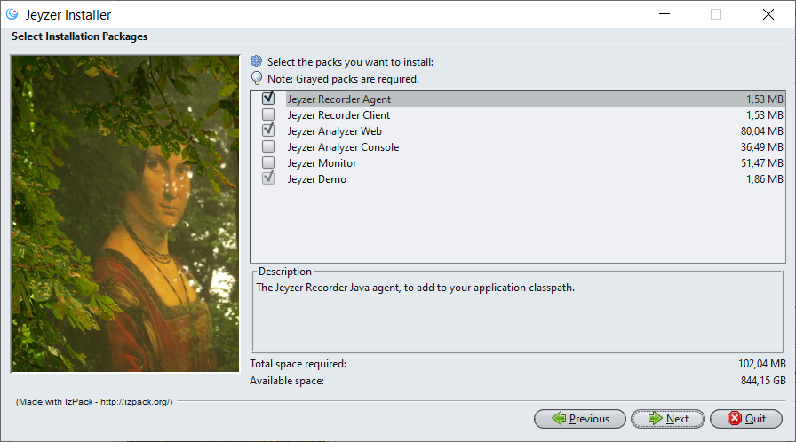

Variant Sahara

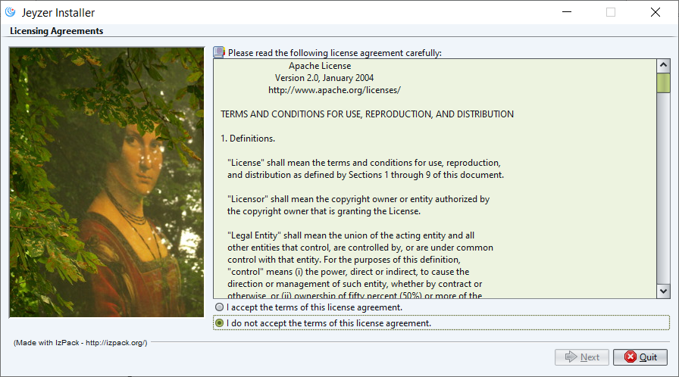

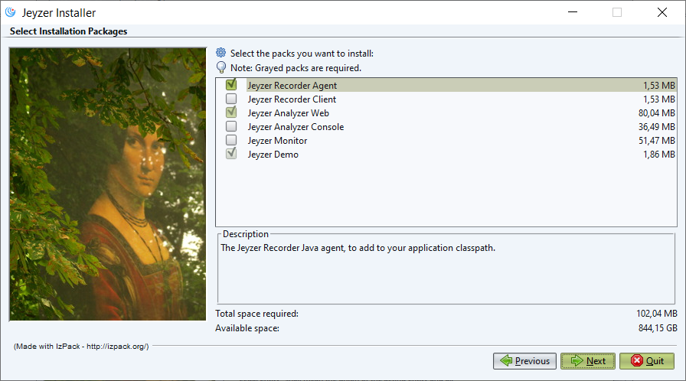

Kunstoff

Note: 5/10

Less readable

Kunstoff – Java 8

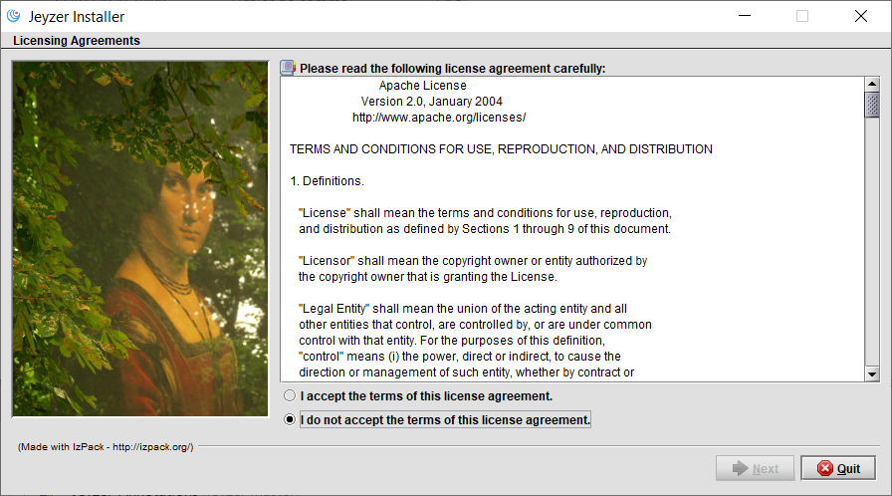

Kunstoff – Java 11

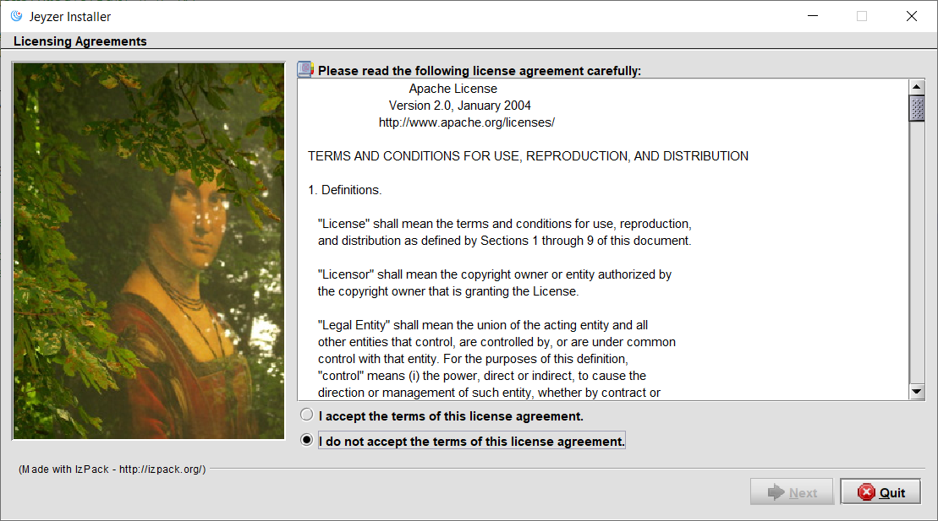

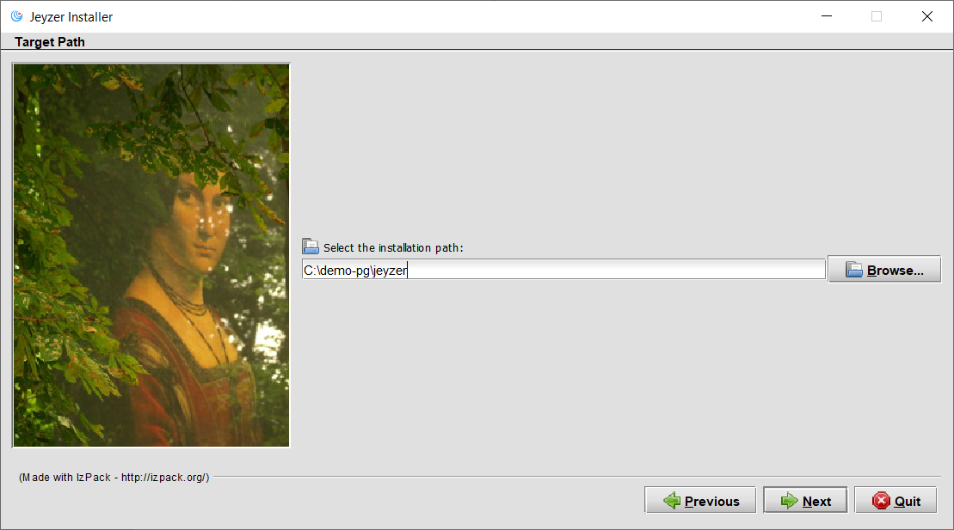

Looks

## Windows variant

Note 7/10

Buttons not well displayed

Java 11

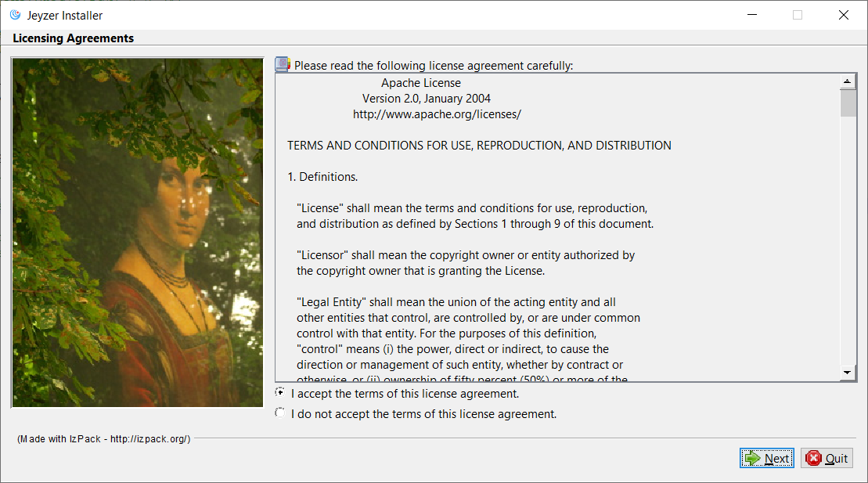

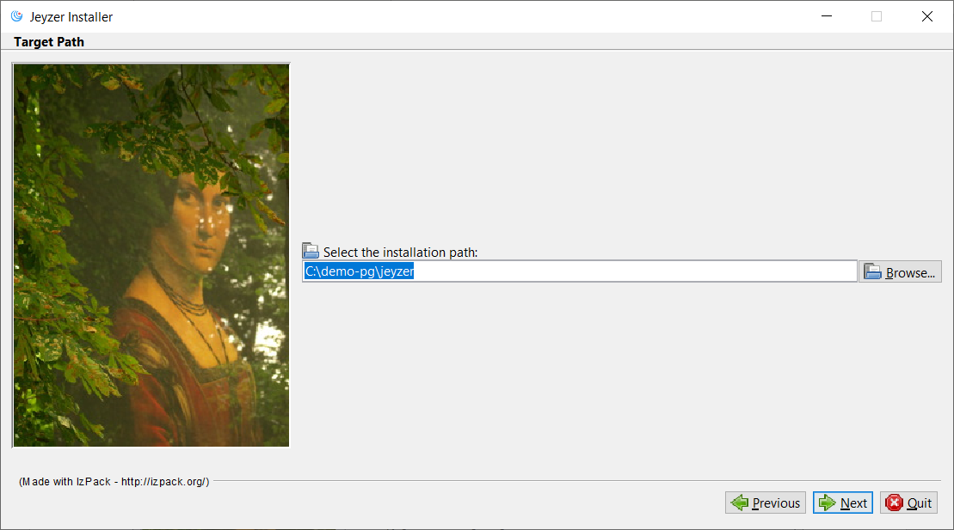

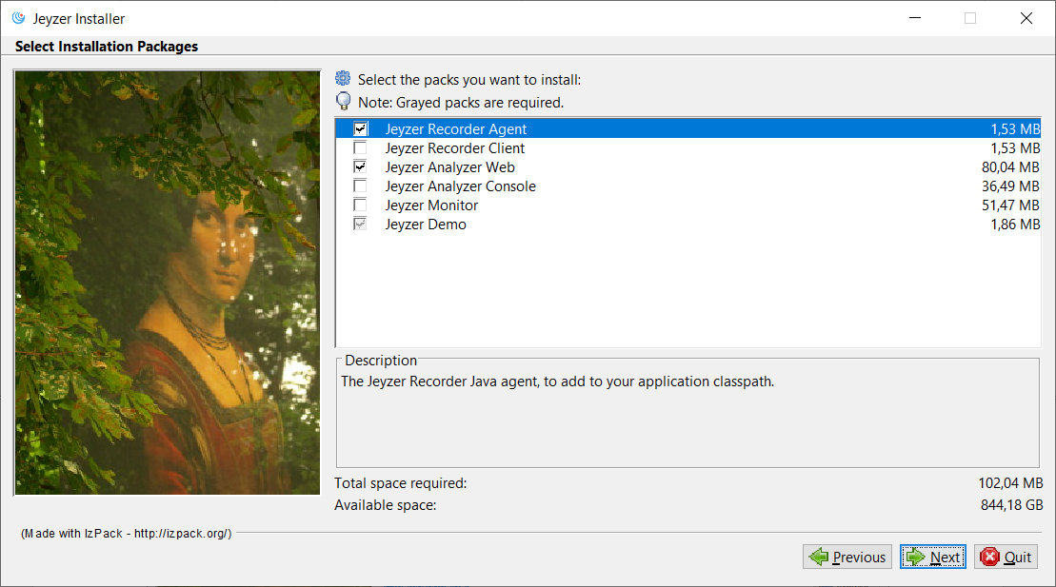

Java 8

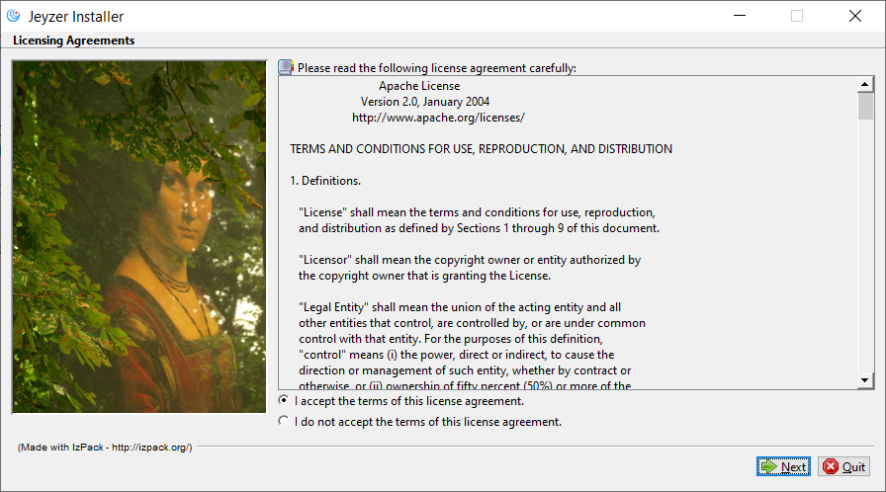

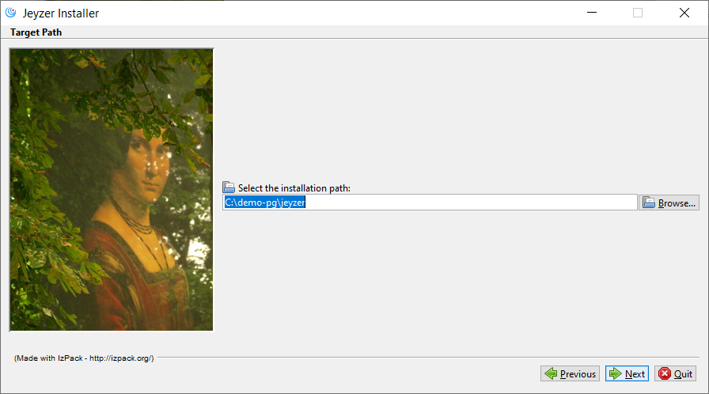

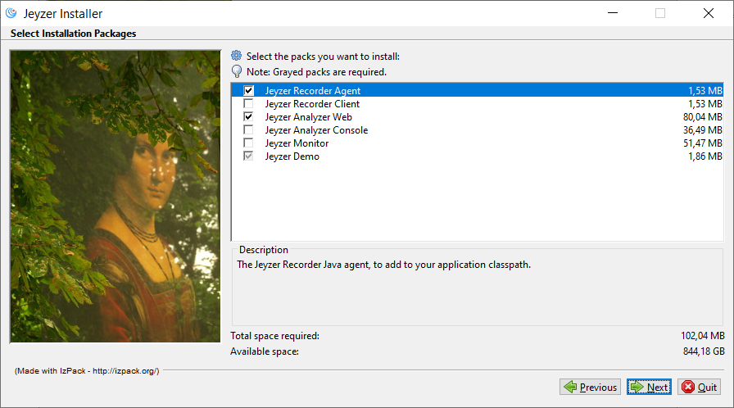

## Plastic variant

Note : 4/10

Java 8

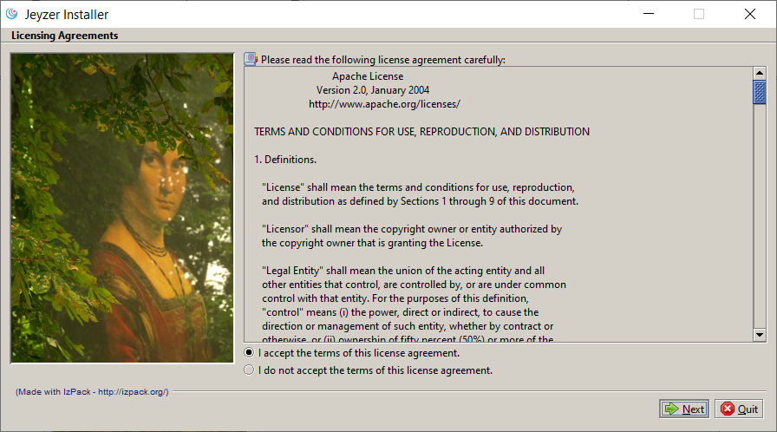

## Plastic3D variant

Note : 7/10

Buttons well displayed

More professional

Bad color

Java 8

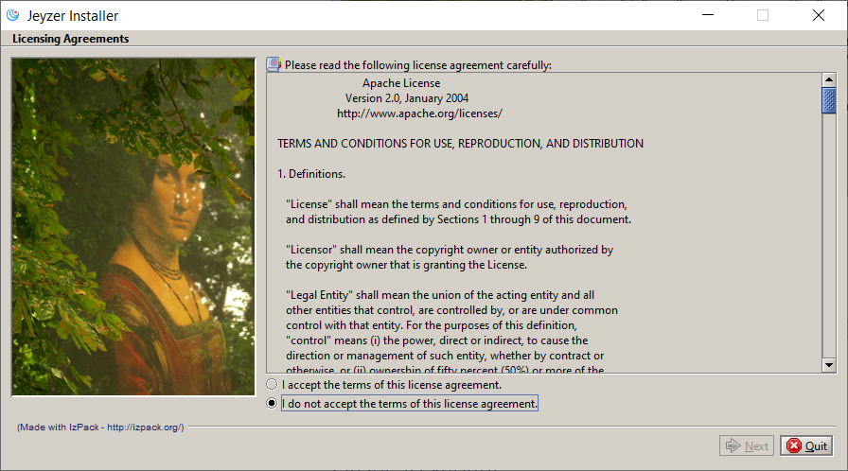

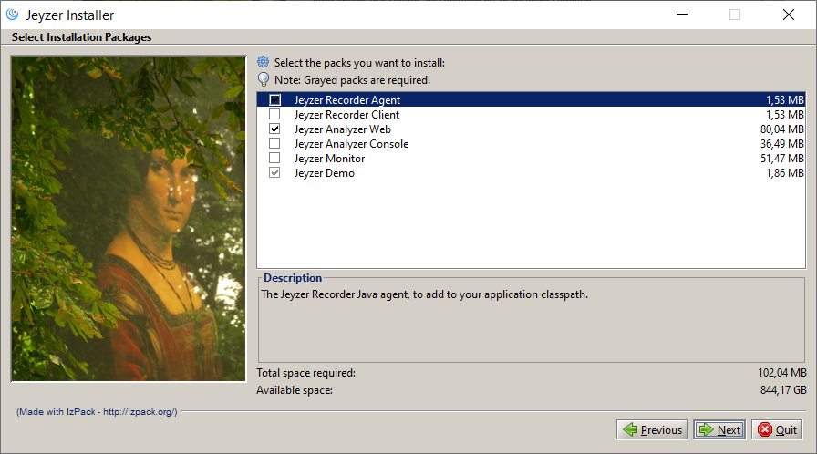

Java 11

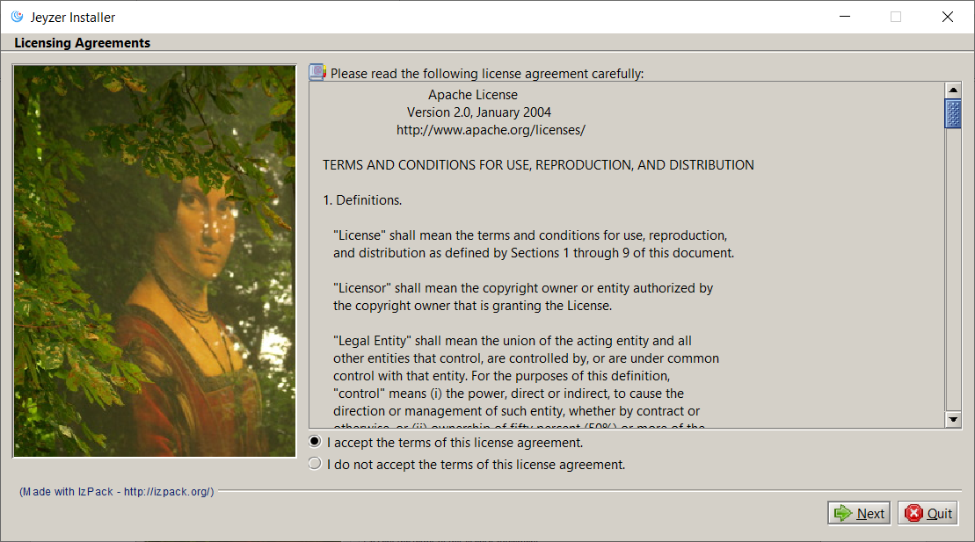

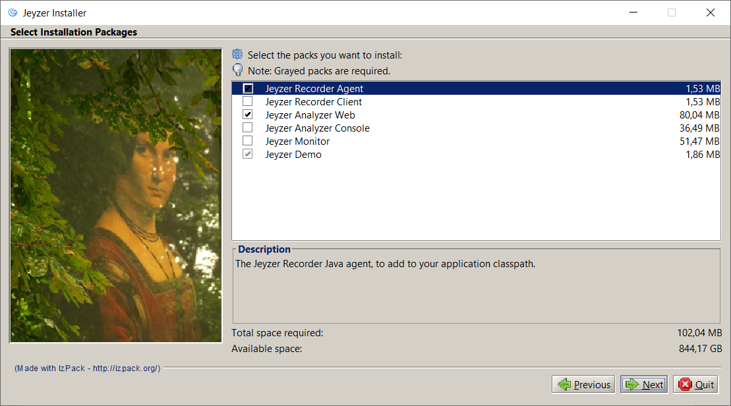

## PlasticXP variant

Note: 7/10

Buttons well displayed

More professional

Bad color

Java 8

